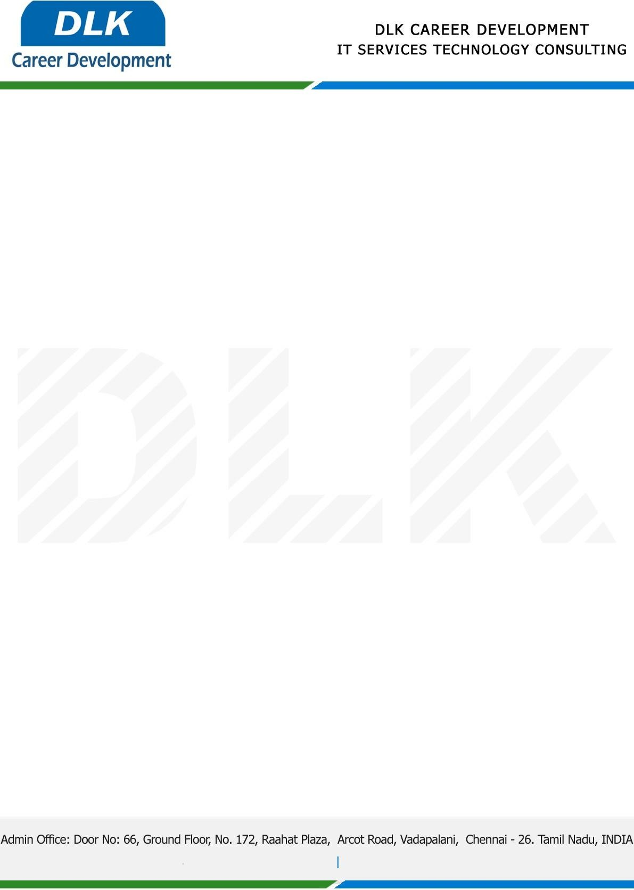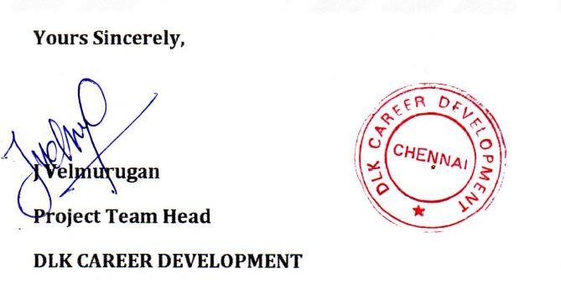

Date: 03 / January/ 2023

**To**

Department of BCA ([Computer Application),](https://www.cseindia.org/) Head of Department,

Shri Krishnaswamy College for Women , Chennai - 600040.

# Sub: Letter of Project Acceptance

This is to certify that **MS CHESNA PREM KUMAR N (REG NO: 212004066)** final year student of has accepted her Project Work duration from **January 2023** to **March 2023** under the domain **“Java”.** During the internship, all information and data collected from you should be kept confidential.

**Topic:** Real Time Emergency aid System with Analysis Vehicle Breakdown Finder Assistance and the Services.

We appreciate your interest in **DLK CAREER DEVELOPMENT**